**MZUMBE UNIVERSITY**



**FACULTY OF SCIENCE AND TECHNOLOGY**

**(FST)**

**PROGRAMME:** DIPLOMA IN INFORMATION TECHNOLOGY.

**COURSE NAME:** MAINTAINING COMPUTER SYSTEM.

**COURSE CODE:** CSS 062.

**LECTURER’S NAME:** MR. KURIHO.

**TASK:** GROUP ASSIGNMENT

**GROUP NUMBER:** GROUP 04

**SUBMISSION:** 10th JANUARY, 2024.

**PARTICIPANTS**

|  |  |  |
| --- | --- | --- |
| **S/N** | **NAMES** | **REGISTRATION NUMBER** |
| 1 | KELVIN MKONYI | 14233033/T.23 |
| 2 | CYINTHIAN IPYANA | 14233025/T.23 |
| 3 | NOEL SWAI | 14233048/T.23 |
| 4 | JOSEPH MAFUNI | 14233047/T.23 |
| 5 | REGINA KASIGWA | 14233020/T.23 |

**INTRODUCTION**

* **Maintenance:**

Maintenance in the context of computer usage refers to the regular tasks performed to keep a computer running smoothly and efficiently. This includes activities such as deleting temporary files, defragmenting the hard drive, running virus scans, and regularly updating software to keep it secure and efficient

According to the maintenance we study and practices to our group we found two computers which have the problem in system software. So we have to fix those computer problems in order to make those computers to function properly.

The first computer problem was

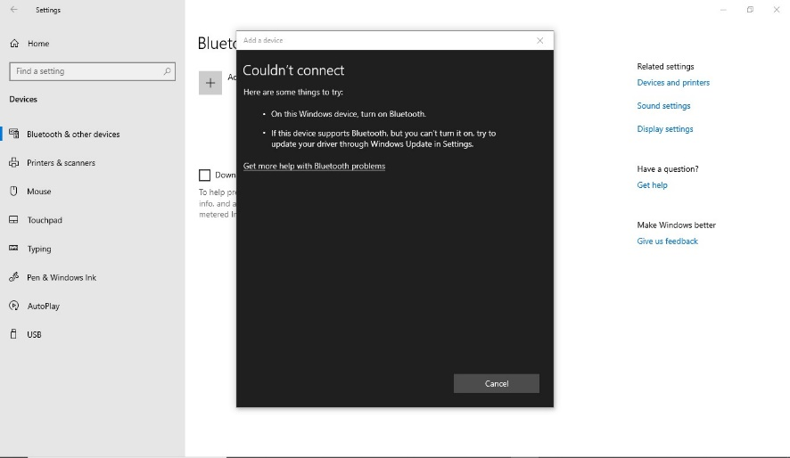

Second computer problem is:

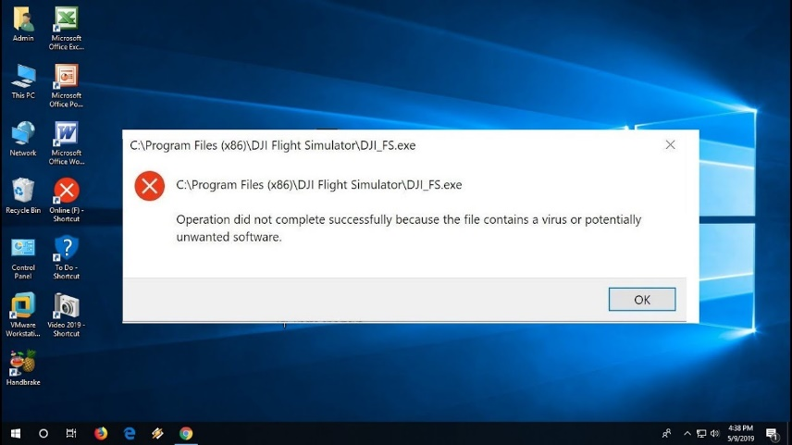

**First problem to solve was:**

We start maintenance of a computer which have the problem of Bluetooth drives. causes of this problem is windows outdated. So we have to update windows in order those drivers to be installed or other latest version of Bluetooth driver to be installed. This computer specifications are RAM 4GB, processor core i5, speed 2.50GHz.

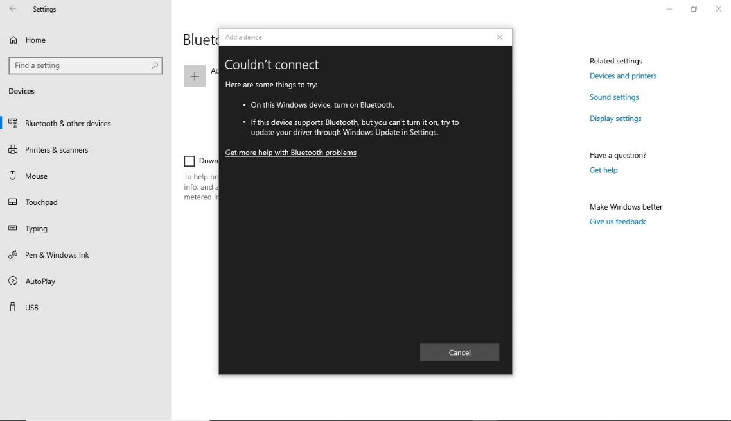

**Potential solution for that problem.**

* **Check for updates for windows update.**

In windows 10, click the start button and then click on settings select update & security and then click on windows update to check for updates. After checking for update, you can install them by following the on-screen instructions and Windows periodically checks for updates and installs them automatically. However, you can still manually check for updates that have been released since the last updates check ran, as well as check for any optional new features.

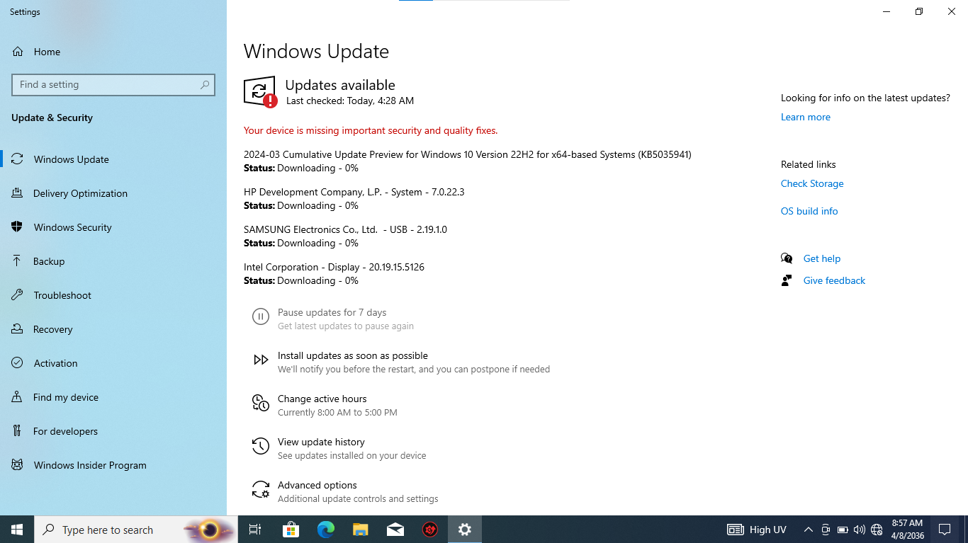

* **Restart your computer:**

After windows installs an automatic update, it may prompt you to reboot your computer. If you see a message asking you to reboot (or schedule a reboot), follow the on-screen instructions to do so.

Remember, keeping your windows system updated.

If windows are already updated windows and Bluetooth still not function because of drivers. **Another solution is:**

* **Uninstall the Bluetooth driver:**

In device manager, select Bluetooth, then press and hold (or right-click) the Bluetooth adapter name and select “uninstall device” >” uninstall”.

Restart your computer:

After your device shuts down, wait a few seconds, and then turn it back on. Windows will attempt to reinstall the driver automatically. Manually Reinstall the driver: if windows don’t reinstall the driver automatically, open device manager and select action.

After finish that maintenance Bluetooth can function properly. As it shown down in picture the Bluetooth is function.

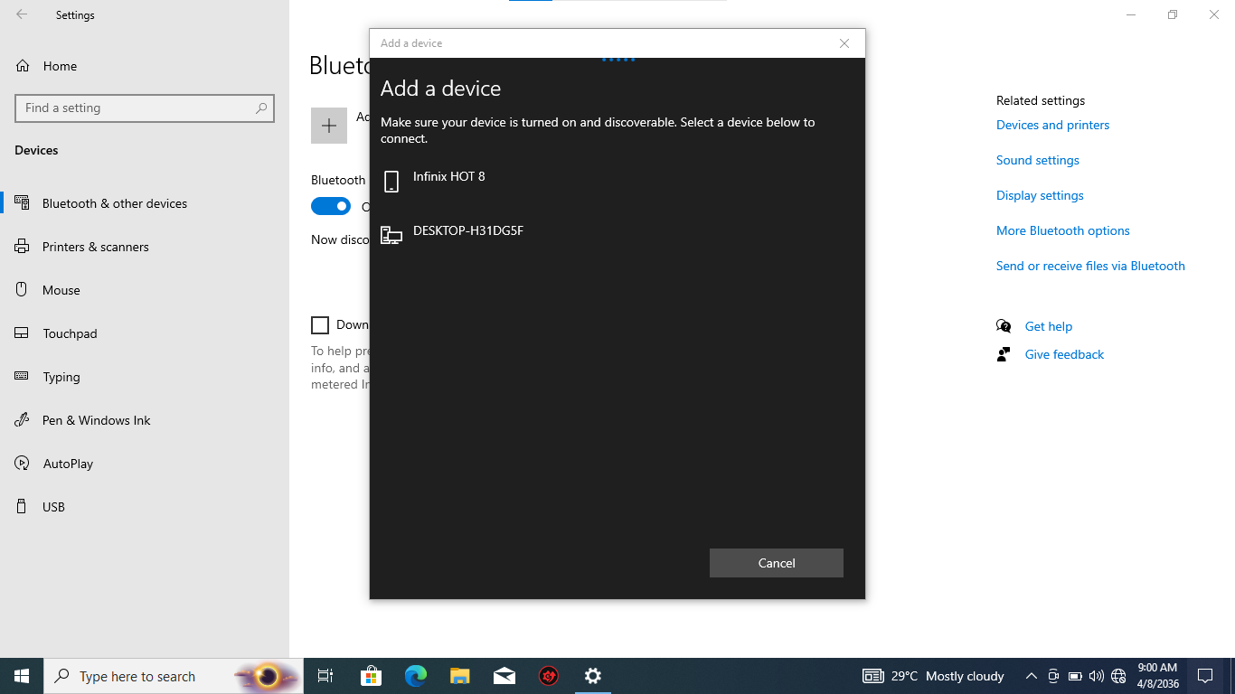

**Another computer problem and its solution.**

We found computer type HP which has the problem in software. The problem was windows to corrupt. So the solution we decide is to install new windows if possible. We check computer specification can allow what type of windows to be installing. Computer specification allow us to install any windows with 64Bits or 32Bits. According to our group we decide to install windows10. Specification RAM 8GB, processor core i3, speed 2.60GHz.

This picture down shows a message we get when open any application in this computer which its windows have corrupted.



**Solution for this problem.**

* **Create flash disc bootable.**

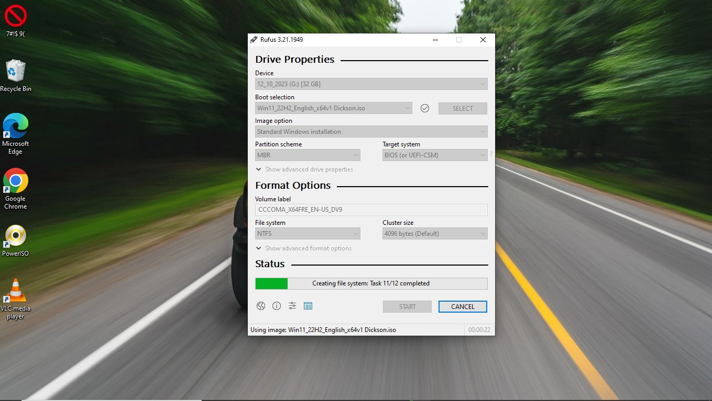

**Switch off the computer for few minutes,** and then switch on in order to start installation.

After computer to be switched on Press the F9 multiple times before the windows to run on disc. The Boot manager menu will open

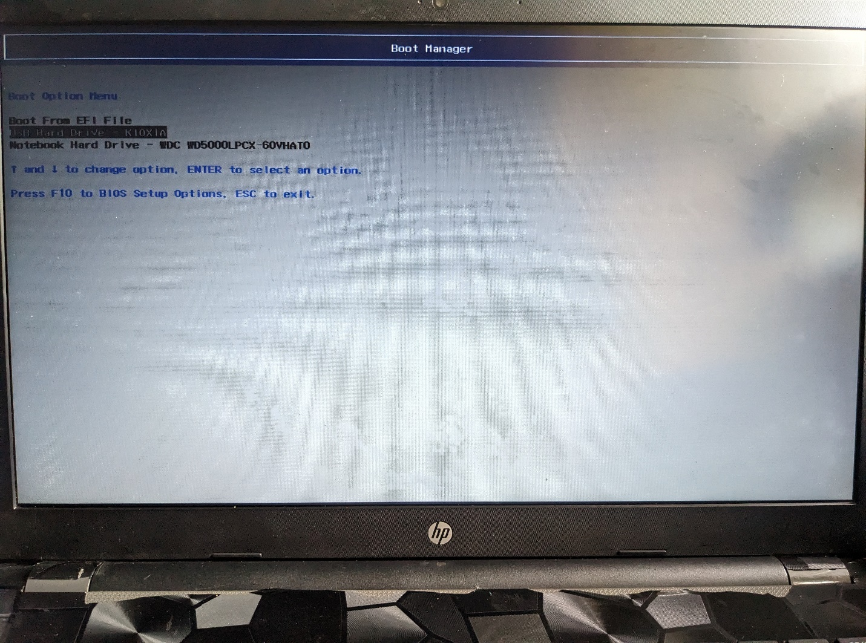

After shown the boot option menu Select the drive unit that contain the Windows 10 image example flash disc or DVD. A message appears press Any key to start installation. After that follow the procedures of installation.

This picture below shows option of choosing language and type of keyboard you can use when install the operating system.

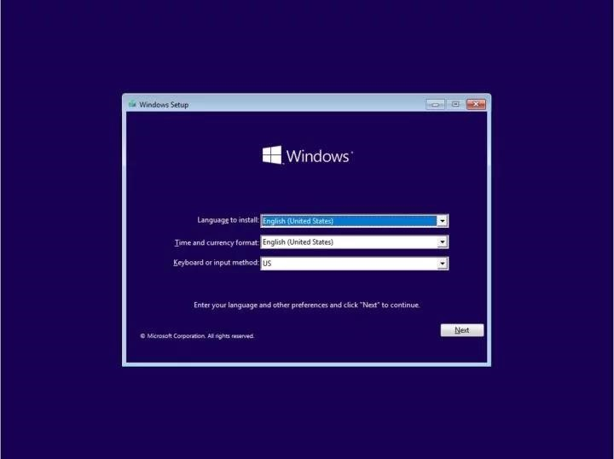

Down here is a message or picture shown to click in order the windows installation in a pc.

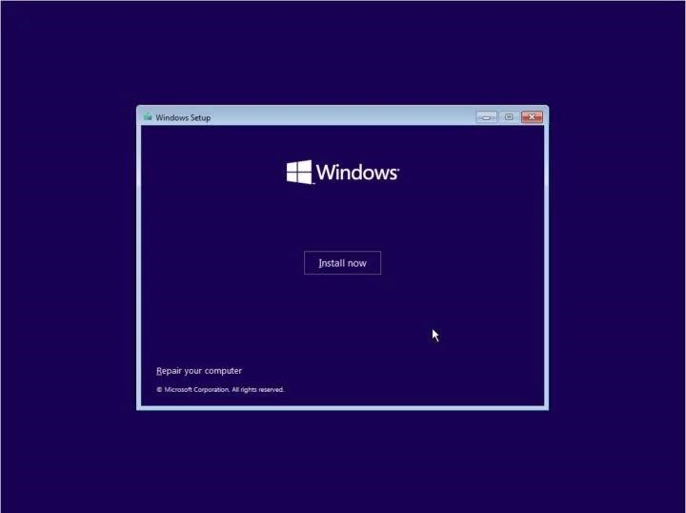

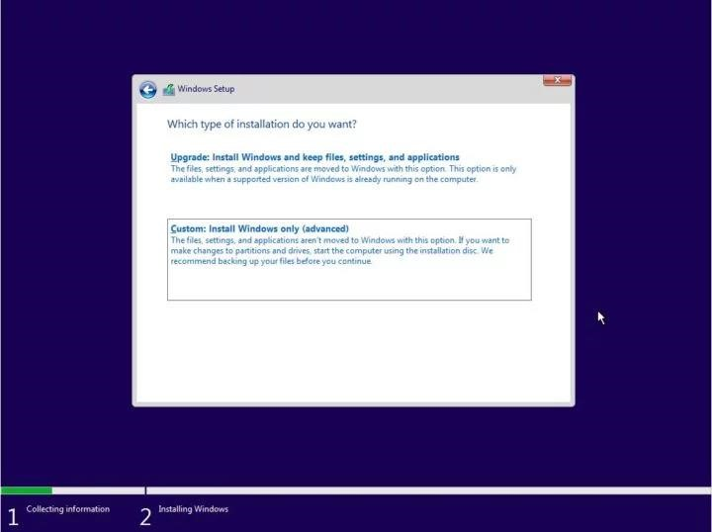

Here way to choose partition where your operating system can be installed.

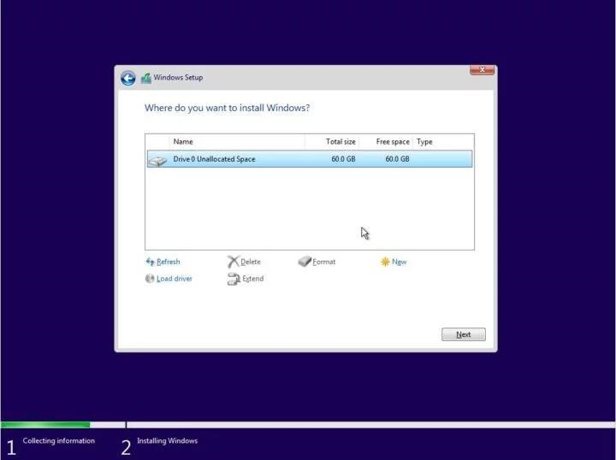

After finish the installation computer can restart automatically.

Computer can switch on and may start another setup of new operating system in a computer.

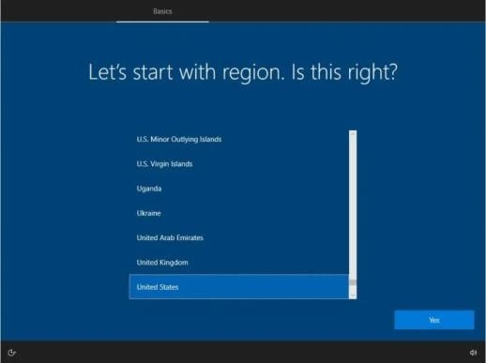

**Final**

Here down show final process when install windows. And it welcome user to start use it.

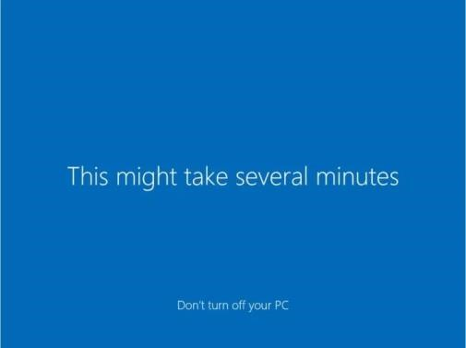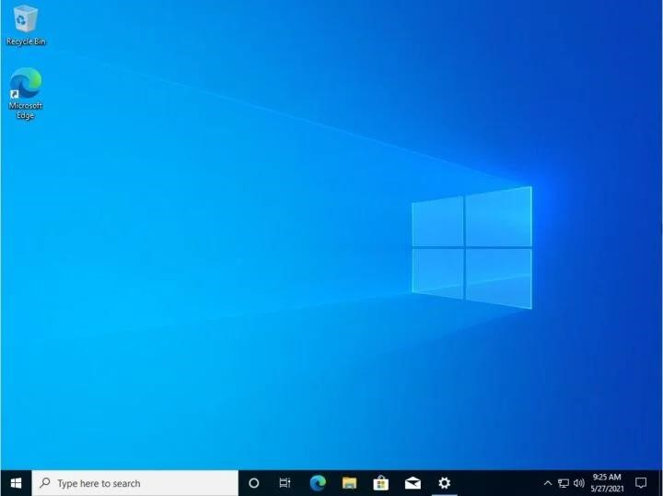

**All in all**

Its better before starting use new windows you must update all the drivers to avoid some of problem which can occurs in drivers like Bluetooth and other software.